**CHAPTER 1**

**OBJECTIVE**

The primary objective of the digital money awareness campaign in Abbigere, Bangalore was to encourage the adoption of digital financial practices, aiming to enhance financial inclusion and economic empowerment within the community. Given the increasing global shift towards cashless transactions, this initiative sought to educate, engage, and empower the local population by providing them with the necessary knowledge and resources to transition smoothly to digital financial systems.

By addressing various aspects of digital finance, the campaign aimed to promote safer, more efficient, and more convenient financial transactions while reducing the risks associated with cash handling. The long-term vision was to instill financial literacy and encourage a shift in mindset, making digital payments a preferred and habitual mode of transaction for individuals and businesses alike.

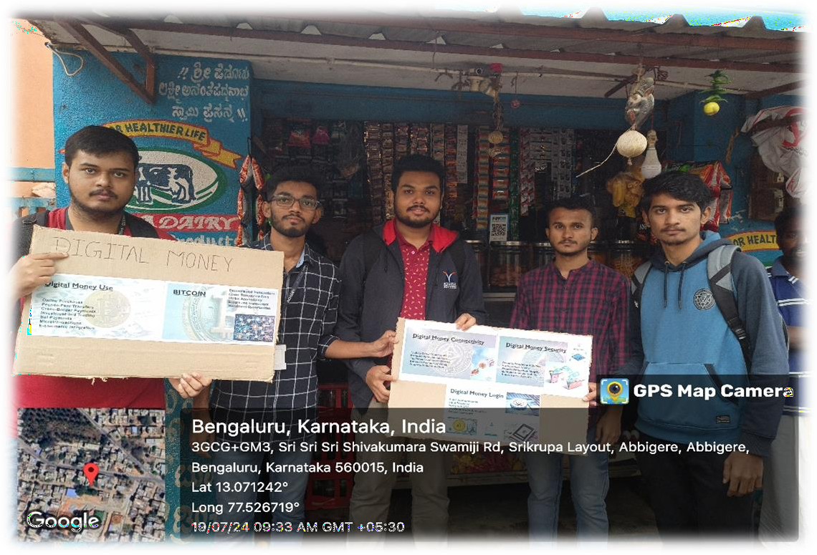

Specific Goals of the Initiative

To achieve its broader mission, the campaign was structured around seven key objectives, each addressing a critical aspect of digital financial empowerment.

**1. Promotion of Digital Money Usage**

The campaign aimed to increase the use of digital payment methods such as UPI, mobile wallets, and net banking among residents and businesses in Abbigere.  
It demonstrated how cashless transactions can be faster, safer, and more convenient compared to traditional cash handling.  
Local businesses were encouraged to implement digital payment options to improve efficiency and customer convenience.

**2. Raising Awareness on Digital Transactions**

Educating people on the advantages of using digital money, including its role in reducing theft, fraud, and cash-related mishandling was a core objective.  
The campaign highlighted how digital transactions contribute to greater financial transparency and help in tracking expenses.  
Information was shared about government initiatives supporting digital payments, such as Digital India and BHIM UPI adoption programs.

**3. Enhancing Digital Literacy**

Digital literacy is crucial for enabling people to use financial technologies effectively.  
The campaign provided informational pamphlets, workshops, and one-on-one guidance to explain:

* How to **set up and use mobile banking apps**
* How to **link bank accounts with UPI and digital wallets**
* How to **ensure cybersecurity while making digital transactions**

**4. Encouraging Behavioral Change**

A major challenge in adopting digital payments is breaking the habit of using cash.  
The campaign aimed to encourage a long-term shift by demonstrating:

* How digital payments **simplify everyday transactions**
* How small businesses and local vendors **benefit from digital payments**
* The safety and **ease of tracking expenses without carrying physical cash**

**5. Engaging the Community**

The campaign focused on building trust and motivating residents to actively participate in the digitaleconomy.  
Efforts were made to foster open discussions to address concerns about digital payments and resolve_misconceptions.  
Community leaders, shop owners, and local influencers were involved to spread awareness effectively.

**6. Supporting Economic Growth**

The campaign encouraged **local businesses** to embrace digital payment methods, which:

* Improves financial security by reducing dependency on cash
* Increases customer convenience as more people prefer cashless transactions
* Prevents revenue loss due to counterfeit currency or cash mismanagement

**7. Spreading Awareness on Financial Security**

One of the key focuses was educating people about digital security and the safe use of online transactions.  
Best practices were taught to prevent fraud, phishing scams, and unauthorized access to bank accounts.  
Guidance was provided on recognizing secure payment platforms and avoiding the sharing of sensitive financial details.

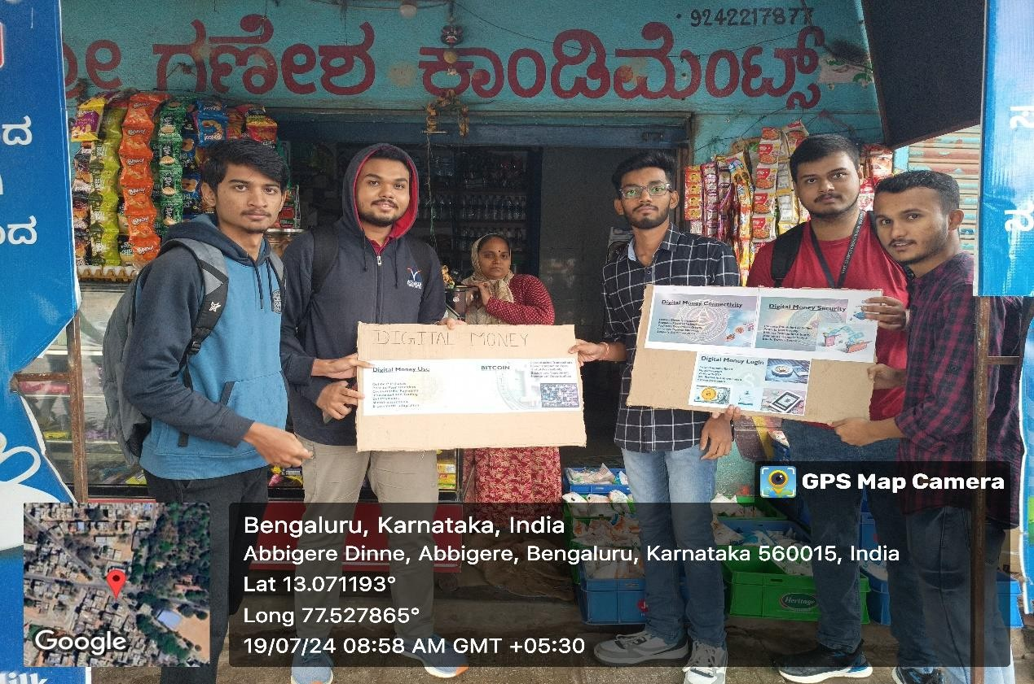

**CHAPTER 2**

**ABOUT THE PLACE**

Abbigere is a rapidly developing locality situated in the northern part of Bangalore, Karnataka. It is approximately 15 kilometers from the city center and falls within the Greater Bangalore region. Over the years, Abbigere has transformed from a predominantly rural settlement into a semi-urban neighborhood, witnessing significant infrastructural and commercial growth. Despite urbanization, it still retains some characteristics of a suburban area, with a mix of residential layouts, small businesses, and patches of greenery.

**Demographics and Community Structure**

The population of Abbigere consists of a diverse mix of people, including local Kannada-speaking residents, working professionals, students, and migrants from different parts of the state and country. The presence of a growing number of educational institutions, healthcare facilities, and commercial establishments has led to an influx of people seeking better opportunities in the area. The locality has a strong sense of community, with traditional values coexisting alongside modern influences brought in by younger professionals and students.

**Economic and Commercial Growth**

Abbigere has experienced steady economic growth, driven by the expansion of local businesses, retail stores, and service sectors. Small-scale industries, local markets, and trade centers contribute to the economic activities in the region. The presence of banking institutions, grocery stores, and shopping centers has made it a self-sustained locality, reducing the dependency of residents on the city center for everyday needs. However, despite these advancements, cash transactions still dominate local businesses, which is why initiatives promoting digital money adoption are essential for financial modernization.

**Educational and Technological Influence**

With the growing emphasis on education, Abbigere has several schools, colleges, and coaching centers catering to students from various backgrounds. Many students residing in the area commute to reputed institutions in Bangalore. The younger population, being more technologically inclined, plays a crucial role in influencing the adoption of digital financial services. Digital literacy programs conducted in the region have the potential to create a long-term impact, encouraging the transition from cash-based transactions to digital payment methods.

**Infrastructure and Connectivity**

Abbigere is well-connected to key areas of Bangalore through major roads and public transportation services. The locality has access to frequent bus services, auto-rickshaws, and cab facilities that link it to important commercial and residential hubs such as Yeshwanthpur, Jalahalli, and Mathikere. The upcoming metro expansion and ongoing road development projects are expected to enhance connectivity further, making Abbigere an even more accessible and well-integrated part of Bangalore’s urban landscape.

**Cultural and Social Aspects**

Abbigere has a vibrant cultural environment where traditional practices and modern lifestyles blend seamlessly. Local festivals such as Ugadi, Deepavali, and Sankranti are celebrated with enthusiasm, bringing together the community for various social and religious activities. The presence of temples, parks, and community centers fosters social engagement among residents. At the same time, the younger generation is increasingly adopting digital lifestyles, which presents an opportunity to bridge the gap between traditional financial habits and modern digital transactions.

**Challenges in Financial Modernization**

Despite its rapid growth, Abbigere still faces challenges in adopting cashless transactions fully. Many small business owners and elderly residents are unfamiliar with digital payment systems, leading to hesitation in transitioning from cash-based transactions. Limited digital literacy, concerns about transaction security, and a lack of awareness about the benefits of digital money are some of the barriers preventing complete financial transformation. The introduction of digital literacy programs and awareness campaigns aims to address these challenges by educating the community on the advantages of adopting digital financial solutions.

**CHAPTER 3**

**CONDUCTION OF THE ACTIVITY**

The initiative to promote digital money in Abbigere, Bangalore, was carried out through a well-structured and organized approach. The campaign was designed to ensure maximum engagement and participation from the local community. A team of dedicated students led the effort, working closely with residents, shop owners, and small business operators to create awareness about the benefits of digital payments. The activity was conducted in multiple phases, including planning, execution, engagement, and evaluation to ensure a systematic approach to promoting financial inclusion.

**Planning and Preparation**

Before launching the campaign, a detailed plan was developed to outline the objectives, strategies, and methods for promoting digital money. The team conducted preliminary research on the current financial habits of the residents and businesses in Abbigere. This included surveys and informal discussions to assess their familiarity with digital payments and the challenges they faced in adopting them.

Once the research was completed, educational materials such as brochures, pamphlets, and posters were prepared to explain the advantages of digital transactions, security measures, and the ease of using digital payment methods. Additionally, a strategy was developed to address potential concerns related to digital fraud, transaction failures, and the accessibility of digital banking services.

**Implementation and Awareness Campaign**

The campaign was launched at key locations within Abbigere, including marketplaces, residential areas, small businesses, and public spaces. The implementation phase involved direct interaction with the community to encourage the adoption of digital financial practices. The activities conducted as part of this initiative included:

**1. Demonstrations of Digital Payment Methods**

One of the most effective strategies used in the campaign was live demonstrations of various digital payment methods, including UPI transactions, mobile wallets, and net banking. Residents were shown how to use applications like Google Pay, PhonePe, and Paytm for making payments and transferring money. Special emphasis was placed on teaching elderly residents and small business owners who were less familiar with digital financial tools.

**2. Engaging Local Businesses and Vendors**

Shopkeepers, street vendors, and small business owners were encouraged to adopt digital payment systems by explaining the advantages of cashless transactions. The team assisted businesses in setting up digital payment platforms, linking their bank accounts, and understanding how to maintain transaction records. Business owners who were hesitant were reassured by highlighting the security and convenience of digital transactions.

**3. Distribution of Educational Materials**

Pamphlets and brochures containing step-by-step guides on using digital money were distributed across Abbigere. These materials covered topics such as how to register for UPI services, how to link bank accounts with mobile wallets, and how to recognize and prevent online financial fraud. The goal was to ensure that people had a reference to help them navigate digital transactions even after the campaign ended.

**4. Conducting Interactive Sessions and Public Discussions**

To engage the community further, interactive sessions were organized in small groups where residents could ask questions and clear doubts about digital payments. Common concerns, such as transaction security, internet dependency, and fraud prevention, were addressed through discussions with financial experts and student volunteers. These sessions helped in dispelling myths and encouraging people to trust digital payment systems.

**5. Providing Hands-On Assistance**

Many residents and business owners required one-on-one assistance to set up their digital payment systems. The team members personally guided individuals through the process of installing banking and payment applications, linking their accounts, and making their first transactions. By offering personalized support, the campaign ensured that participants gained confidence in using digital payment methods.

**6. Spreading Awareness Through Word of Mouth and Community Leaders**

The involvement of local influencers and community leaders played a crucial role in encouraging residents to adopt digital payments. Religious leaders, business association members, and prominent figures in the community were briefed about the importance of digital transactions. Their endorsement helped gain the trust of the residents, making them more open to trying out digital payment solutions.

**Challenges Faced and Overcoming Them**

Despite the structured approach, the campaign faced several challenges in convincing some individuals to shift from cash-based transactions to digital payments. The main challenges included:

* **Resistance to Change:** Some residents, especially older individuals, were reluctant to change their traditional way of handling money. The campaign addressed this by demonstrating the security and ease of digital transactions.
* **Limited Awareness and Digital Literacy:** Many people were unaware of how digital payment systems worked. The team provided patient, step-by-step guidance to educate them.
* **Concerns About Cybersecurity:** Fear of fraud and online scams was a major deterrent. To counter this, the campaign emphasized security measures such as two-factor authentication and safe banking practices.
* **Lack of Internet Access or Smartphones:** A small section of the population did not have access to internet-enabled smartphones. In such cases, alternative solutions such as SMS-based banking and assisted transactions were suggested.

**Impact and Observations**

The campaign had a notable impact on the financial behavior of the residents of Abbigere. Many individuals and businesses adopted digital payment methods as a result of the awareness drive. The key outcomes observed included:

* A significant increase in the number of shopkeepers and vendors using QR code-based payments.
* A rise in UPI transactions among younger individuals and working professionals.
* Greater awareness about financial security and fraud prevention.
* Positive feedback from community members who found digital transactions more convenient and time-saving.

**CONCLUSION**

The promotion of digital money in Abbigere, Bangalore, has been a significant step toward fostering financial inclusion and encouraging the adoption of modern, cashless transactions. Through a well-structured campaign involving awareness programs, live demonstrations, and personalized assistance, the initiative successfully introduced residents and businesses to the benefits of digital payments. By addressing concerns related to security, accessibility, and usability, the campaign helped overcome many of the barriers that initially prevented people from embracing digital financial solutions.

One of the key takeaways from the initiative was the positive shift in financial behavior among the community members. Many shopkeepers, vendors, and individuals started incorporating digital payment methods into their daily transactions, contributing to a safer, more efficient, and transparent financial ecosystem. The campaign also highlighted the importance of digital literacy, ensuring that individuals not only learned how to use digital payment systems but also understood the best practices for secure and responsible financial management.

Despite some initial resistance and technological barriers, the initiative demonstrated that persistent education, hands-on engagement, and community involvement are crucial for driving meaningful change. The response from the residents of Abbigere was encouraging, with many pledging to continue using digital financial services and promoting their benefits within their social circles.

Moving forward, it is essential to sustain and expand such efforts, ensuring that more individuals, especially those in underserved communities, gain access to digital financial tools. Continued awareness campaigns, government incentives, and infrastructure improvements will further strengthen the transition toward a fully digital economy. Through collective efforts, initiatives like this can help bridge the digital divide and empower communities with the knowledge and resources needed to thrive in an increasingly cashless world.